Swachhata Action Plan 2020-21

- Renovation and repairing work of Toilet at King George Medical University, Lucknow.
- Arrangement of Clean potable water to the students/staff at Nagar Nigam Balika Inter Collage, Kanpur.
- Distribution of Jute Bags and Plants among staff and public.
- Distribution of Large Dustbin to the Govt. residential colony and schools.
- Decoration of office premises with natural plants.
- Shramdan Activities done by staff and officers of NACIN, Kanpur. Also placed posters depicting message “Swachhta Hi Sewa” at various spots.

Photographs
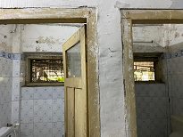

(Renovation of Toilet of K.G.M.C, Lucknow)
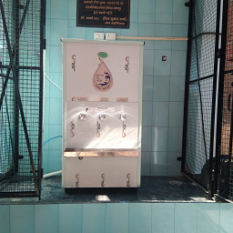 | 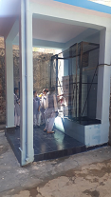
(Project of Clean potable water at Nagar Nigam Balika Inter Collage, Heeraman Purwa, Kanpur)

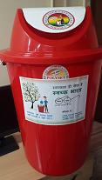 | 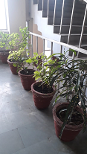
(Dustbin Distribution) | (Plantation at Office)

